
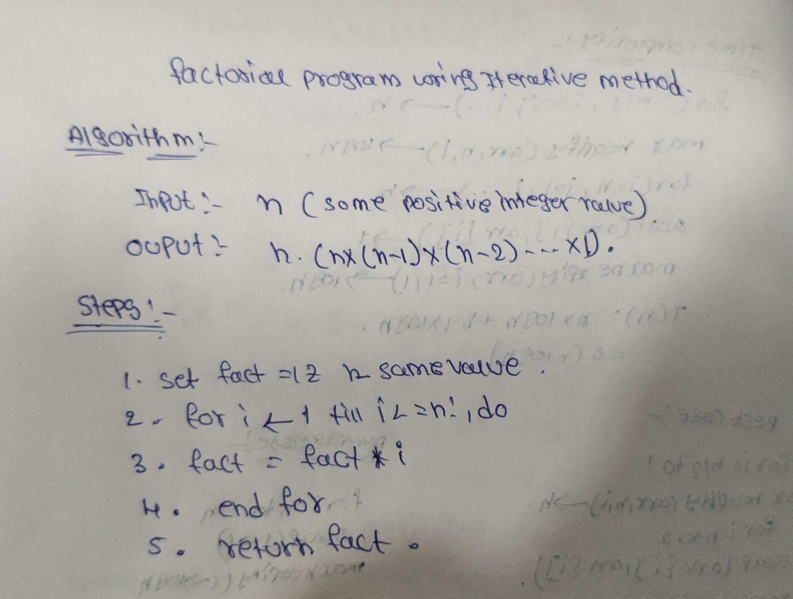

PRACTICAL-4
AIM: Implementation and Time analysis of factorial program using iterative and recursive method.

Factorial Using Iterative Method ALGORITHM:

CODE:
#include <iostream> using namespace std; int factorial(int n)
{
int fact = 1;
for(int i = 1; i <= n; i++)
{
fact = fact * i;
}
return fact;


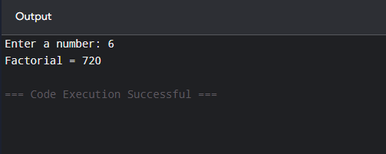
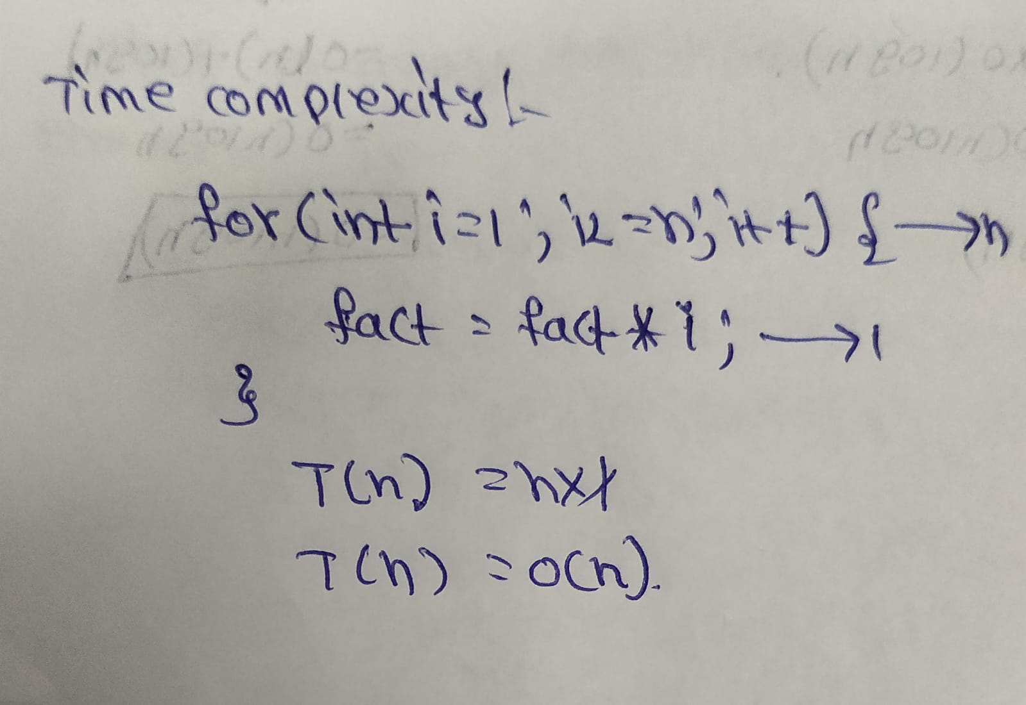
}

int main()
{
int n;
cout << "Enter a number: "; cin >> n;

cout << "Factorial = " << factorial(n);

return 0;
}
OUTPUT:

TIME COMPLEXITY:


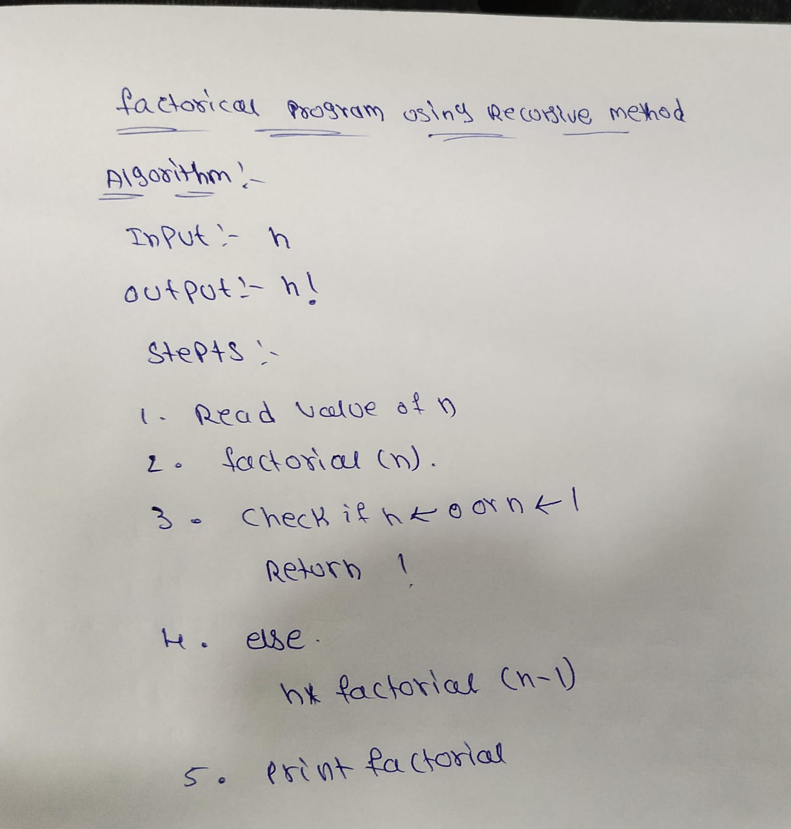

Factorial Using Recursive Method: Algorithm:

CODE:
#include <iostream> using namespace std; int factorial(int n)
{
if(n == 0 || n == 1)
{
return 1;
}


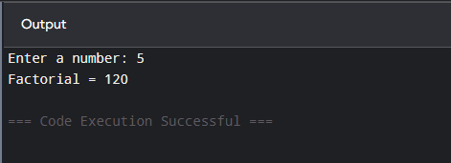
return n * factorial(n - 1);
}
int main()
{
int n;
cout << "Enter a number: "; cin >> n;
cout << "Factorial = " << factorial(n); return 0;
}

OUTPUT:

TIME COMPLEXITY:


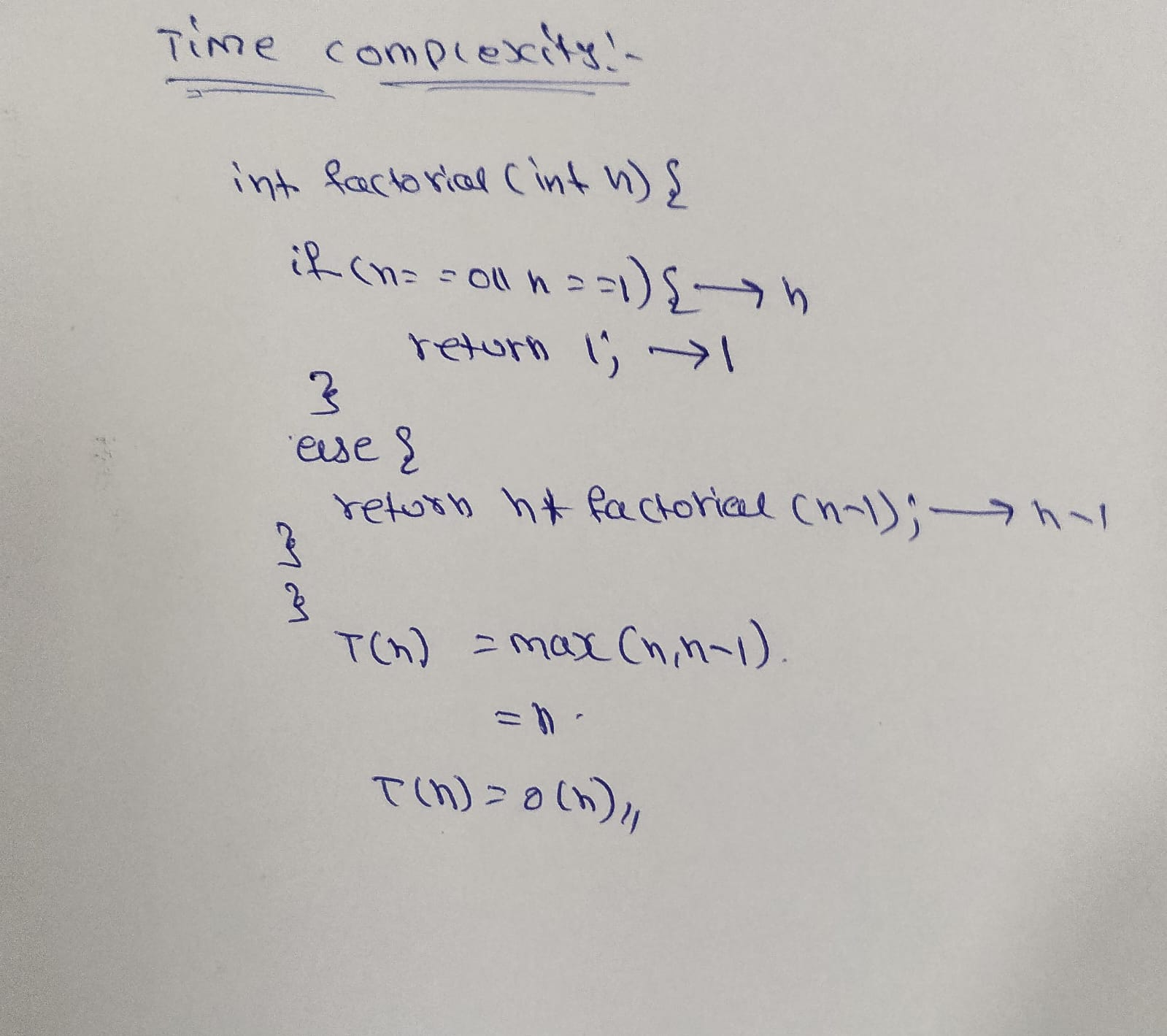

CONCLUSION:

The factorial program was successfully implemented using both iterative and recursive methods. Both methods produce the same result, but the recursive method uses function calls and stack space. The time complexity of both methods is O(n), making them efficient for calculating factorials.

